**加快编译速度 --> [传送门](http://blog.csdn.net/yunnywu/article/details/48471407)**

**去掉热编译**

Setting -> Buid,Execution,Deployment -> Instant Run -> 去掉全部

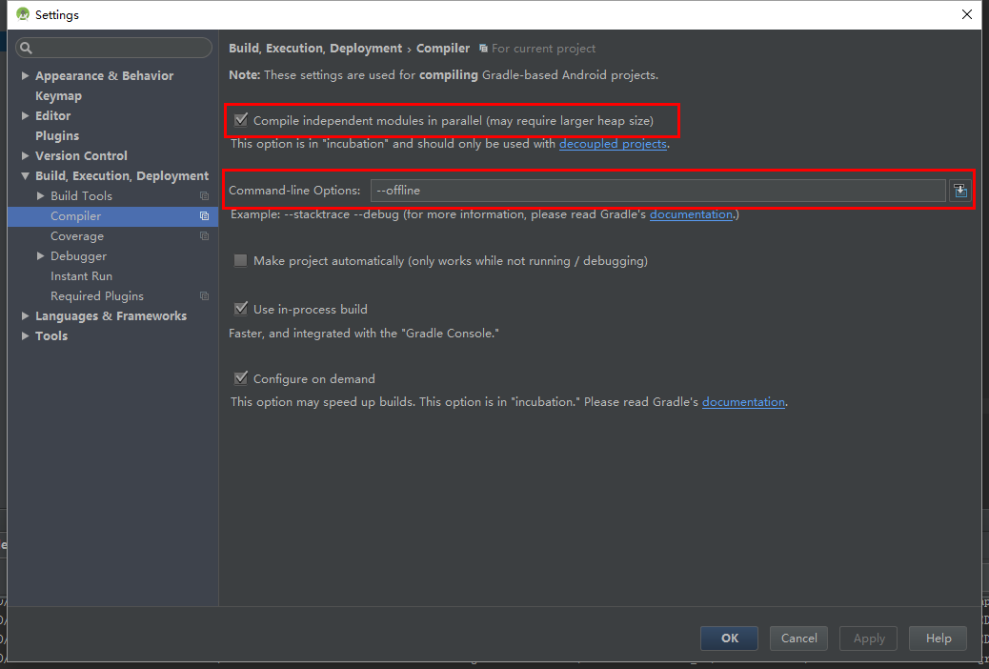

设置gradle.progerties

# Project-wide Gradle settings.  
  
# IDE (e.g. Android Studio) users:  
# Settings specified in this file will override any Gradle settings  
# configured through the IDE.  
  
# For more details on how to configure your build environment visit  
# http://www.gradle.org/docs/current/userguide/build_environment.html  
  
# The Gradle daemon aims to improve the startup and execution time of Gradle.  
# When set to true the Gradle daemon is to run the build.  
# *TODO: disable daemon on CI, since builds should be clean and reliable on servers*org.gradle.daemon=true  
  
# Specifies the JVM arguments used for the daemon process.  
# The setting is particularly useful for tweaking memory settings.  
# Default value: -Xmx10248m -XX:MaxPermSize=256m  
org.gradle.jvmargs=-Xmx5120M -XX:MaxPermSize=512m -XX:+HeapDumpOnOutOfMemoryError -Dfile.encoding=UTF-8  
  
# When configured, Gradle will run in incubating parallel mode.  
# This option should only be used with decoupled projects. More details, visit  
# http://www.gradle.org/docs/current/userguide/multi_project_builds.html#sec:decoupled_projects  
org.gradle.parallel=true  
  
# Enables new incubating mode that makes Gradle selective when configuring projects.  
# Only relevant projects are configured which results in faster builds for large multi-projects.  
# http://www.gradle.org/docs/current/userguide/multi_project_builds.html#sec:configuration_on_demand  
org.gradle.configureondemand=true  
  
org.gradle.workers.max=10

**修改 studio.xxx.vmoptions文件。**

-Xms518m（启动时的内存）  
-Xmx2048m（运行时的内存）

AS2.2 快速分析你的APK

